OCR PROGRAMMING
COURSEWORK
ROBERT STARCK
MAY 2025

Table of Contents
Analysis 3
Introduction 3
Problem Identification 4
Computational Methods 7
Summary table 9
Stakeholders 10
Summary table 11
Research Existing Software 12
Summary table 18
Features of Proposed Solution 19
Limitations of the Proposed Solution 20
Requirements 21
Hardware Requirements 21
Software Requirements 21
File Requirements 21
Success Criteria 23
Design 29
Problem Decomposition 29
Required Files and Entity-Relationship Diagram 29
Initial data files with justification 29
Top-Down Design – script n 29
Pseudocode – script n 29
Top-Down Design – script n+1 29
Pseudocode – script n + 1 29
Usability Features 29
Data Dictionary 29
Validation 29
Initial Test Data Plan 29
Iterative Development and Design 30
Iteration 1 30

Analysis

Introduction
My Client, Mrs Elliot, is a computer science teacher at Shenley Brook End School, https://www.sbeschool.org.uk. She is also a form tutor for the sixth form at Shenley. She is both my computer science teacher and form tutor. She is currently getting frustrated with the current computer system used to take and manage registers and attendance.
One of the many tasks that she must do repeatedly, as a form tutor and teacher, is to look at the attendance for every student in her form and compare it with the standards set by the school. If it is subpar, below 95%, she needs to have a word with that student. However, she has the issue of not being able to check which lessons were missed for that student and if it was an error on the teacher’s behalf, and she doesn’t like how the student also can’t see which lessons they got marked as absent for. She also would like to be able to sort by attendance to make it easier to see who she needs to have a word with as this is not currently and option. She also doesn’t like how she cannot amend register’s part a specific point in time if they do need to be amended, and sometimes she also forgets to do the register so having a reminder pop up would make her life much easier as well. So, she has asked me to design a new register system to replace the current system, Arbor (https://login.arbor.sc).

Problem Identification
!How the task is currently done
!Proposed change

What data do they need, where does it come from?
How is it currently stored?
How is it used
How often is it updated?

Checking the attendance and how it is displayed
Attendance view with students with lower attendance at the top and sorted, flags next to each person with info, if needed. Option to step into to see when the student was absent.
Main menu
Search for student by name (usually)
Pick form menu on the left “attendance -> marks by date” doesn’t let choose date -tabular format – too bulky
All days
Ticks for marked present – doesn’t like
Series of codes – seems to be random – hover over to find out– key on the right will help.
percent value in a pdf that needs to be downloaded but can be printed (good).
Are statistics in attendance menu?
Dashboard gives brief overview (useful)
One of the tasks my client must do is review the attendance of all the students in her form. To do this she must first log in to the existing system, into the main menu. Then she needs to search for the student’s name in the search bar at the top. The go into the attendance menu on the left and then the submenu attendance menu, to give a brief overview of the attendance of that student. Or she can go into the marks by date to get a timetable for the whole year for that one student with all their marks for each lesson on each day. These are marked by a tick for present or characters which she does not remember which each character stands for and has to hover each one every time to remind her of what they all mean. Another option she has is to download an attendance certificate which is generated by the current system to display a brief overview of the attendance at the top and more in-depth information throughout the rest of the document. She likes the brief overview of the statistics in the attendance menu and does not want that change. However, she doesn’t like the format of the marks by date view. One of the issues is you can’t choose the date for which is shows you to or from, so she would like an option to filer it down. She also doesn’t like the system in which the data of the attendance is displayed, first she doesn’t like the ticks and would prefer a forward slash “/”. She also doesn’t like the letters to display other marks as she can never remember them and has asked for a key on the side and a simpler set of characters used so she doesn’t have to keep hovering over them to find out what they mean. This feature will help her out by shortening the amount of time she has to spend combing through all the data and complicated symbols, in her opinion, just to get to the data that she needs. She also likes the attendance certificate as it allows her to print it off and it gives her all the information in one place. She has also requested that there is a new menu in which she can see all the attendance for all students in her form, she would also prefer it if it was ordered lowest attendance to highest attendance and colour coded with red being below 92%, orange from 92% to 97% and green from 97% to 100%. This feature will save her a lot of time as she doesn’t have to individually search up each person in her form and then navigate through all the menus to find the attendance of that one student.

Currently to take the register my client must go to her timetable, click on the current lesson, without validation to check if it is the right lesson, and then click on “Take register” to start taking the register. Then when taking the register, she does have the option to mark all students as present or absent and then change individual students. When marking a student as absent it brings up another window to confirm but this doesn’t happen when marking a student as present. My client would like the new system to hold some of the features in their entirety, build on some others and add some more. My client likes the mark all as absent or present, so I shall keep that as is because there is no need to improve upon it. But she would like a shorthand to mark as absent with a reason, in which case it asks her for a reason, or mark absent without reason and no box pops up and wants to keep the marking present the same. Another feature in the same category she would like is present elsewhere in school as she finds that there is a common issue with the system not understanding when someone has been marked elsewhere as present. Both of these features provide an easier interface to use and makes it faster for her to input all the data in making it a better solution than the existing one. For getting to the register, she would like the system to know what lesson and open the register for that class then, as she sometimes doesn’t remember what lesson it is and sometimes gets the wrong one. She has also requested that the system will automatically fill double lesson registers with one register instead of having to do it twice as she forgets to redo the register while in the middle of teaching. Both features provide quality of life features for my client by making the system automate more and cut out more opportunities for human error which she is struggling with now.
Currently the data for the registers is stored on the existing system, some examples of the data include the class times, names and register marks. All the data is currently used to generate students’ attendance, when lessons are, who is in what class and other bits of information which my coursework is not concerned with. The data must be updated each time a register is taken for updating attendance, but with the timetable it is only updated when a change is made

The current system allows students to login and on their homepage display their overall attendance considering authorised absences and unarmed absences. However, with the current system there is no way to see where they have had those absences, which lessons they missed. My client would like the new system to allow students to enter an area where they can see all previous lessons in a timetable form, but colour coded to display the mark that they got for each lesson. Myt client would also prefer if there was also an option to jump to the lessons missed so if it was a while ago the students don’t have to spend forever looking for that lesson. This will help to increase the rate at which she can look through attendance, as it will be faster if the student can have a look before and say whether it was an incorrect mark or not.
The data for this is currently stored by the current system, this data is the date, lesson number, class name, student first and last name and their register mark. All the data is collected and used to calculate the student’s overall attendance. The data only needs to be update whenever a register is taken.

Computational Methods
5 computational methods and how they are relevant.
Sequence, Iteration, selection, Decomposition, Data storage…
Where they occur +1
Currently where it is present and why it should be computerised in terms of computational methods.
/Amenable/
Short definition for the computational methods
What tasks have to occur with respect to the computation methods?
Iteration, sequencing, decomposition, selection.
Abstraction- what are you leaving out of your prototype.

Problem, current computational methods, amenable to computer use

Sequencing is the computational method to describe the order of execution of tasks in a specific order to complete a task. A repetition of sequence is called iteration. In my coursework my client must, while taking the register, go through each student in turn alphabetically and mark whether they are present or not, this is sequence. And because this is repeated for all students until all students are registered, this is also an example of iteration. This is amenable to computer use due to the computational methods at use. Another example where sequence is used is when my client wants to review the attendance of each student. To view the attendance the registers must first be taken and then saved to the file, this is another example of sequence. But because she must review the attendance for all students this process must be repeated until all students in her form have had their attendance reviewed, it is also iteration. This task is also amenable to computer use due to the computational methods used to complete this task. My client also when choosing menus must go through them in a specific order to get to the section that she needs to be in to complete a specific task. This is an example of sequence and because of this, this task is amenable to computer use.

Another computational method is selection which is the process of a computer choosing a specific task based on a specific condition. In my coursework my client must choose what register mark to give each student, and different register marks lead to different outcomes, different pieces of code run. This is an example of selection. This is amenable to computer use due to the use of selection. Another example is when going through the menus, my client must make a choice on what section she wants to go into. And depending on the choice she makes different operations run, this is also an example of selection. This is also amenable to computer use due to the use of computational methods. Again, in my course work my client must also make choice on who she needs to have words with about their attendance, and different levels of attendance means different outcomes which is, again, selection. This is amenable to computer use as well due to the use of the computational method, selection. Another example of selection is the login, currently the current system checks the data that is input and then compares it against the stored data, and if it matches it lets them into that account, and then depending on the account privileges certain features will be locked or unlocked. This is another example of sequencing and that makes it amenable to computer use.
Decomposition is the breaking down of a complex task into smaller simpler tasks to make completing the main task easier. In my coursework my client breaks down one task into smaller sub tasks, one such example of this is when taking the register, she must look at each individual name then check if they are there and give them a mark. This is an example of decomposition and makes this task amenable to computer use. Another task she also must do is check students’ attendance, this is currently done by searching a student’s name, selecting them from the list of people that show up, then going into their attendance. This is another example of decomposition and makes this task also amenable to computer use.

Abstraction is the computational method which describes the action of leaving out certain details deliberately to make programming the program easier. Currently, in my coursework, my client ignores certain bits of data, for example when taking the register, she doesn’t need to see their overall attendance, or what register marks they got previously as there is no need and it will be more useless information cluttering the screen. This is an example of abstractions and makes this task amenable to computer use. Another task where she uses abstraction is when looking at the list of people in her form whose attendance she must check and talk to people about. When doing this she ignores the picture of them and most other information other than name and their attendance. This is again an example of abstraction and makes this task as well amenable to computer use.

Data storage describes how and where the data that the program needs is stored, for example: cloud or local storage. In my coursework my client inputs the data where it is then stored on the cloud so that other members of the school can access it, this is an example of data storage. This is amenable to computer use due to the computational methods at play here. My client must also be able to store lots of registers in one place which is easy to access from any device in the school. This is another example of data storage. This task is also amenable to computer use due to the computational method. Currently the files needed are, information about students, classes, registers, timetables and teachers. These files are all linked together to help avoid redundancy and reduce the amount of space wasted. This is another example of data storage and is thus amenable to computer use.

Summary table
Computational method Definition Task amenable to this computational method
Bullet points of the tasks mentioned above.
Computational Method | Definition | Tasks amenable to this computational method
Sequencing | Sequencing is the order in which tasks are completed to ensure the task is done correctly | - GO through each student in turn when taking the register.  - To check the attendance of a student a register must be taken first for that attendance to be correct
Iteration | Iteration is the looping of a sequence to get it done multiple times | - When taking the register my client must fill in a register mark for each student  - She must go through and find each student in her form’s attendance
Selection | Selection is the choosing of a task based on whether a condition is met or not | - If the user that logs in has teacher privileges the system will give them access to more functions  - Choosing a register mark when doing the register
Decomposition | Decomposition is the breaking down of a large task into smaller sub tasks | - Taking the register  - Checking students’ attendance
Abstraction | Is the removal of unnecessary data | - Removing certain bits of information from the students when taking the register  - Checking students’ attendance
Data Storage | Data storage is how and where the data is stored | - Stores data on the cloud currently  - All files are linked together to reduce redundancy

Stakeholders
My primary stakeholder during development will be my client, Mrs Elliot. Currently their task is to teach computer science, taking the register at the start of each lesson. This is done by selecting the current class on her timetable and then going through each student and marking down whether they are there or not. She also must manage her forms attendance, which is done by individually searching up each student in her form and checking their attendance manually and determining if it is subpar (below 95%). The proposed solution will benefit her as while taking the lesson she can use the shorthand that will be implemented to make taking the register easier these include short hands to mark everyone as present or absent with no reason, drastically reducing the time taken to take the register and increase teaching time. The system before will output the register to the client so she can check before it is saved to the system. While checking the attendance of her form the proposed solution will provide an option to view all students in her form with their attendance next to each person, and they will be ordered from lowest to highest attendance and will be colour coded to make it easier to see. This cuts down on the time taken to do this be lowering the number of inputs to one which is just a simple select at the start to view the attendance. The proposed solution is appropriate to their needs as it cuts down on the time taken to do the register at the start of each lesson increasing the amount of teaching time, and reducing the time to search though all the students on her form to see if she needs to talk to anyone with low attendance.

Another stakeholder after development will be students. The students will be a secondary stakeholder. Students will also be directly interacting with the system to check out their own attendance and which lessons were missed. Currently their task is to check their own attendance and email the sixth form if they believe there are any issues. This is currently done by them having to guess when they missed the lesson or ask their form tutor to check for them which takes time out of the other things they need to do. The proposed solution will benefit them by providing a way for them to check their own attendance and know what lessons they missed. The students will select to go into the attendance view where they will get their timetable headered with each week start and end date and then each lesson is colour coded to match the register mark that they got for that register. They can also change the view to just displayed when they have been marked absent, on what day and on what lesson. This helps my client by making the student more able to review their attendance on their own first before she must deal with it, saving time in her day to do other more important tasks.

Pastoral leaders would be a tertiary client as they would use the output of the system. Currently they take the information about the attendance of the students and must forward it on to the government and do other data manipulation with it. The current system has no easy way to change the data if it does need to be change and the very limited validation can only be done by a few people so there is low chance that the data will be validated in time. The proposed solution will benefit them as it will be providing them more accurate data as if the students can validate their own attendance and ask to get it amended sooner it will help improve the validity of the data that is received by the school management team.

Summary table
Stakeholder description How they will use the solution Why is it appropriate to their needs.
Stakeholder | Description | How will they use the solution | Why is it appropriate
My client  (primary) | - Taking the register  - Managing her form’s attendance | - They will use the new functions to cut down on the amount of time they spend filling in the empty dialogue boxes.  - They will use the new view to quickly see her whole forms’ attendance in one place. | - It is appropriate as it reduces the time spent to take the register.  - It cuts down on the time taken to check her forms attendance
Students  (primary) | - Email attendance team to get attendance marks fixed | - They will use the solution to more easily see where they have missed attendance marks so they can include that in their email to the team | - It is appropriate to their needs as it cuts down on the time, they need to get their attendance fixed because they no longer have to guess when they were absent
Pastoral leaders  (tertiary) | - Review all student’s attendance and format it to send it off to the government | - They wont directly use the system, but they will use the output of the system to get more accurate data to send off to the government. | - It is appropriate to their needs as it saves them time on trying to fix students attendance.  - Get more accurate data to send off

Research Existing Software
3+ applications
Same basic functionality

Arbor other non-school register systems
See what it not does that your client wants.

{
My system is a blankity blank (register) system.
Name of the system and URL
Screen shot of main menu – gives you the features and functions.
Data capture screenshot – what data they have included.
1+ pictures of the output
What doesn’t it do?

What am I going to include and what will I leave out give reasons for both?
} repeat 3 times.
Summary tables

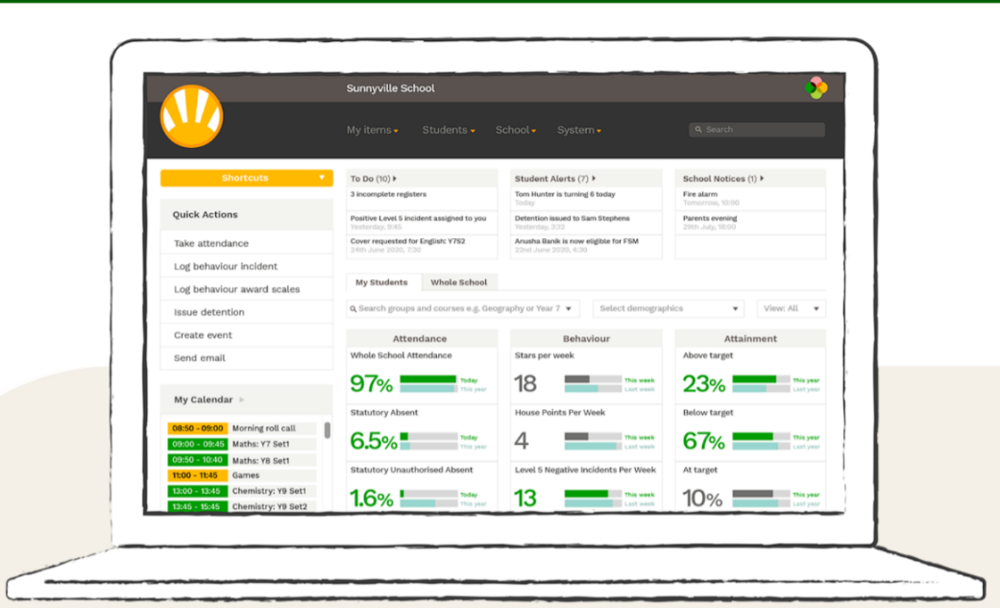
One system I am choosing to research is the current system Arbor https://arbor-education.com.

Arbor is used among many schools for their attendance and register system, it has features to automatically calculate a student’s attendance, their behaviour and attainment. It also has functions to show to do lists and view their timetable to name a couple of functions. They have included data about each student’s attendance, there behaviour and what grades they get in what subjects. They also store the data about the student including name, date of birth etc. Another piece of information that they store is the student’s timetable.
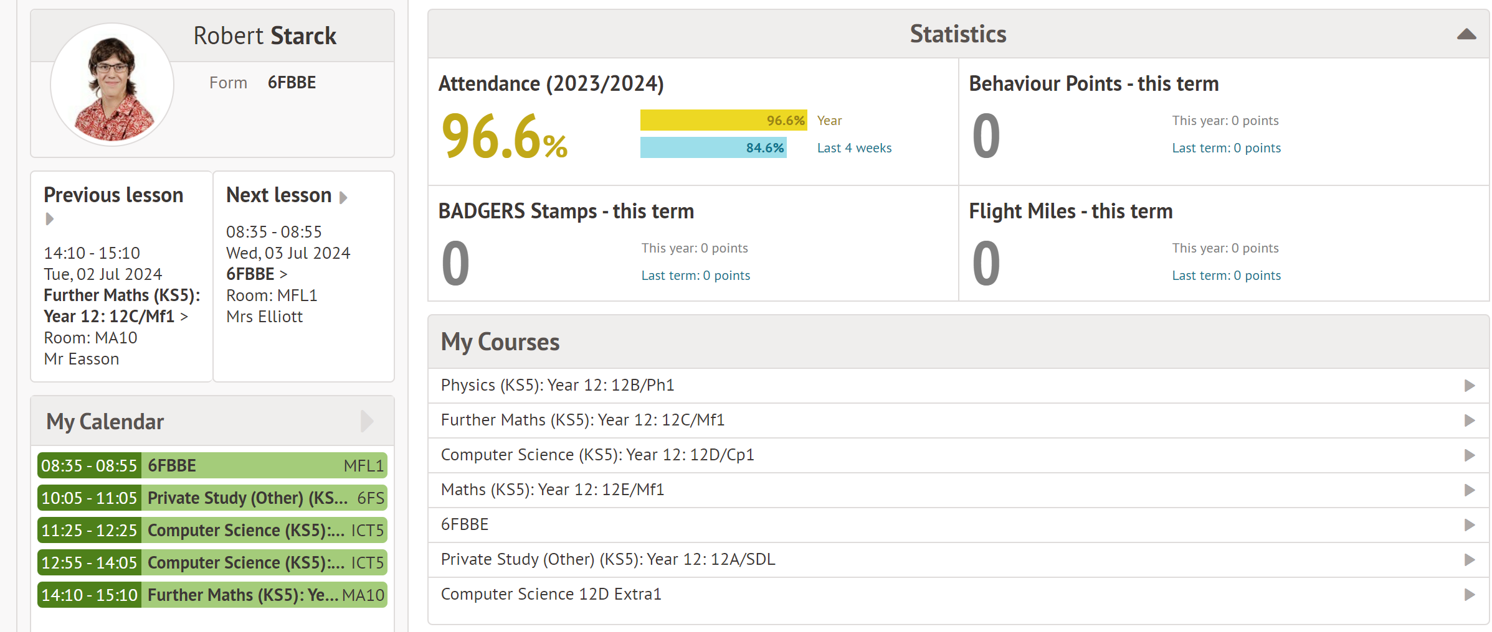
The data that is output by Arbor is overall attendance for the year and attendance for the last 4 weeks. The number of badger stamps received in the year and the last term, same with behaviour points and Flight miles. It also outputs the course they do and their calendar for that day. It also states their last lesson and my next lesson above it. Aswell as displaying their Name, form, and their school picture in the top left which I have blanked out.
Arbor is however missing on the student’s side, for them to get more information about their attendance, for example where they missed lessons. It also does state where those behaviour points where from and expects the student to just know. It is also missing load of shorthand’s for teachers that would make their life much easier, such as when taking the register, the ability to mark without reason without having to enter a separate window. Also, the ability to see attendance for all students with their form, meaning they have to manually search each student’s name and then navigate to where their attendance percentage is.

With respects to my coursework and what my client as asked me for, I am not going to touch on either the attainment or the behaviour part of Arbor. I will however be focusing entirely on the attendance and register systems in Arbor. I will keep the how the attendance is displayed in the student profile on their dashboard as it provides an easy way to quickly view their attendance percentage. But I will be adding functionality to the student side to allow them to see where they have missed lesson, this will be done so that my client doesn’t always have to search for each student whenever they think they have gotten an incorrect and find out where it is for them, they can just do it on their own saving my client time. For the teacher side I will be adding a view for them where it displays all the students in that teacher’s form with the student’s attendance next to their name, it will be ordered by attendance in ascending order, so lowest attendance at the top and highest attendance at the bottom. It will also be colour coded to make visualising who the form tutor needs to talk to easier and faster for her. I will also make changes to the register form, giving more options to use in the main menu rather than making submenus which popup all the time and waste time if there is nothing to fill in.

Another system I looked at was Inventry, https://inventry.co.uk/products/sign-in-solutions/.
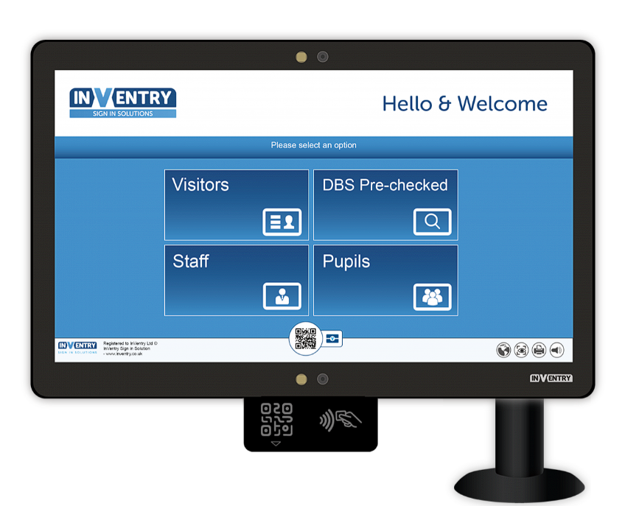
Inventry is also used a registration system and attendance management system which has a specific system for schools, which is what I will be researching. Inventry has functions to mark all students as present and a separate function which leads into all other options, such as late or not present. You can also click into students to see their personal details, or a club overview including what clubs they are in and their attendance for that specific club.
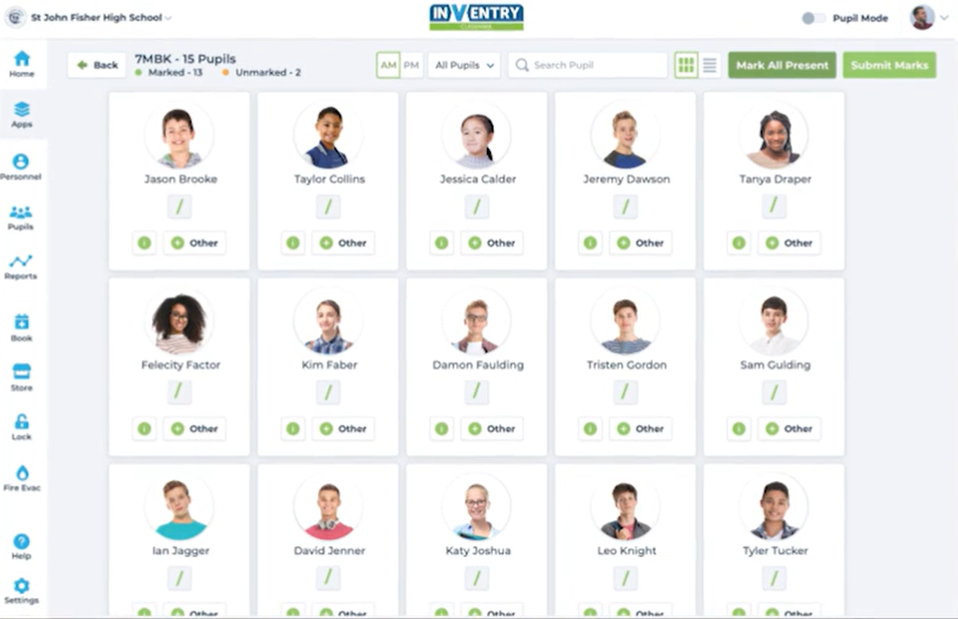
The data that is output to the teacher is a grid of the student’s names, pictures and then the option to mark them present, or any other mark, which opens a new window in which the teacher can enter what mark they should get. If the teacher clicks into a specific student the teacher can also see all the information about the student such as name, date of birth etc… There is also a class view where all the classes for that teacher are listed.
From this system I am going to keep the mark all as present as that is a useful feature that my client has requested in the proposed solution. I will not use the grid format that Inventry use as my client would prefer it in a list view to make it easier to just go down one each time and mark it easier. I will also keep the submit marks as that allows my client another chance to check over it. I will also leave out the button for other as my client has stated that she doesn’t want another dialogue box to have to fill in.

Another system I also looked into is called coacha, https://www.coacha.co.uk/Features/Classes-and-Registers.
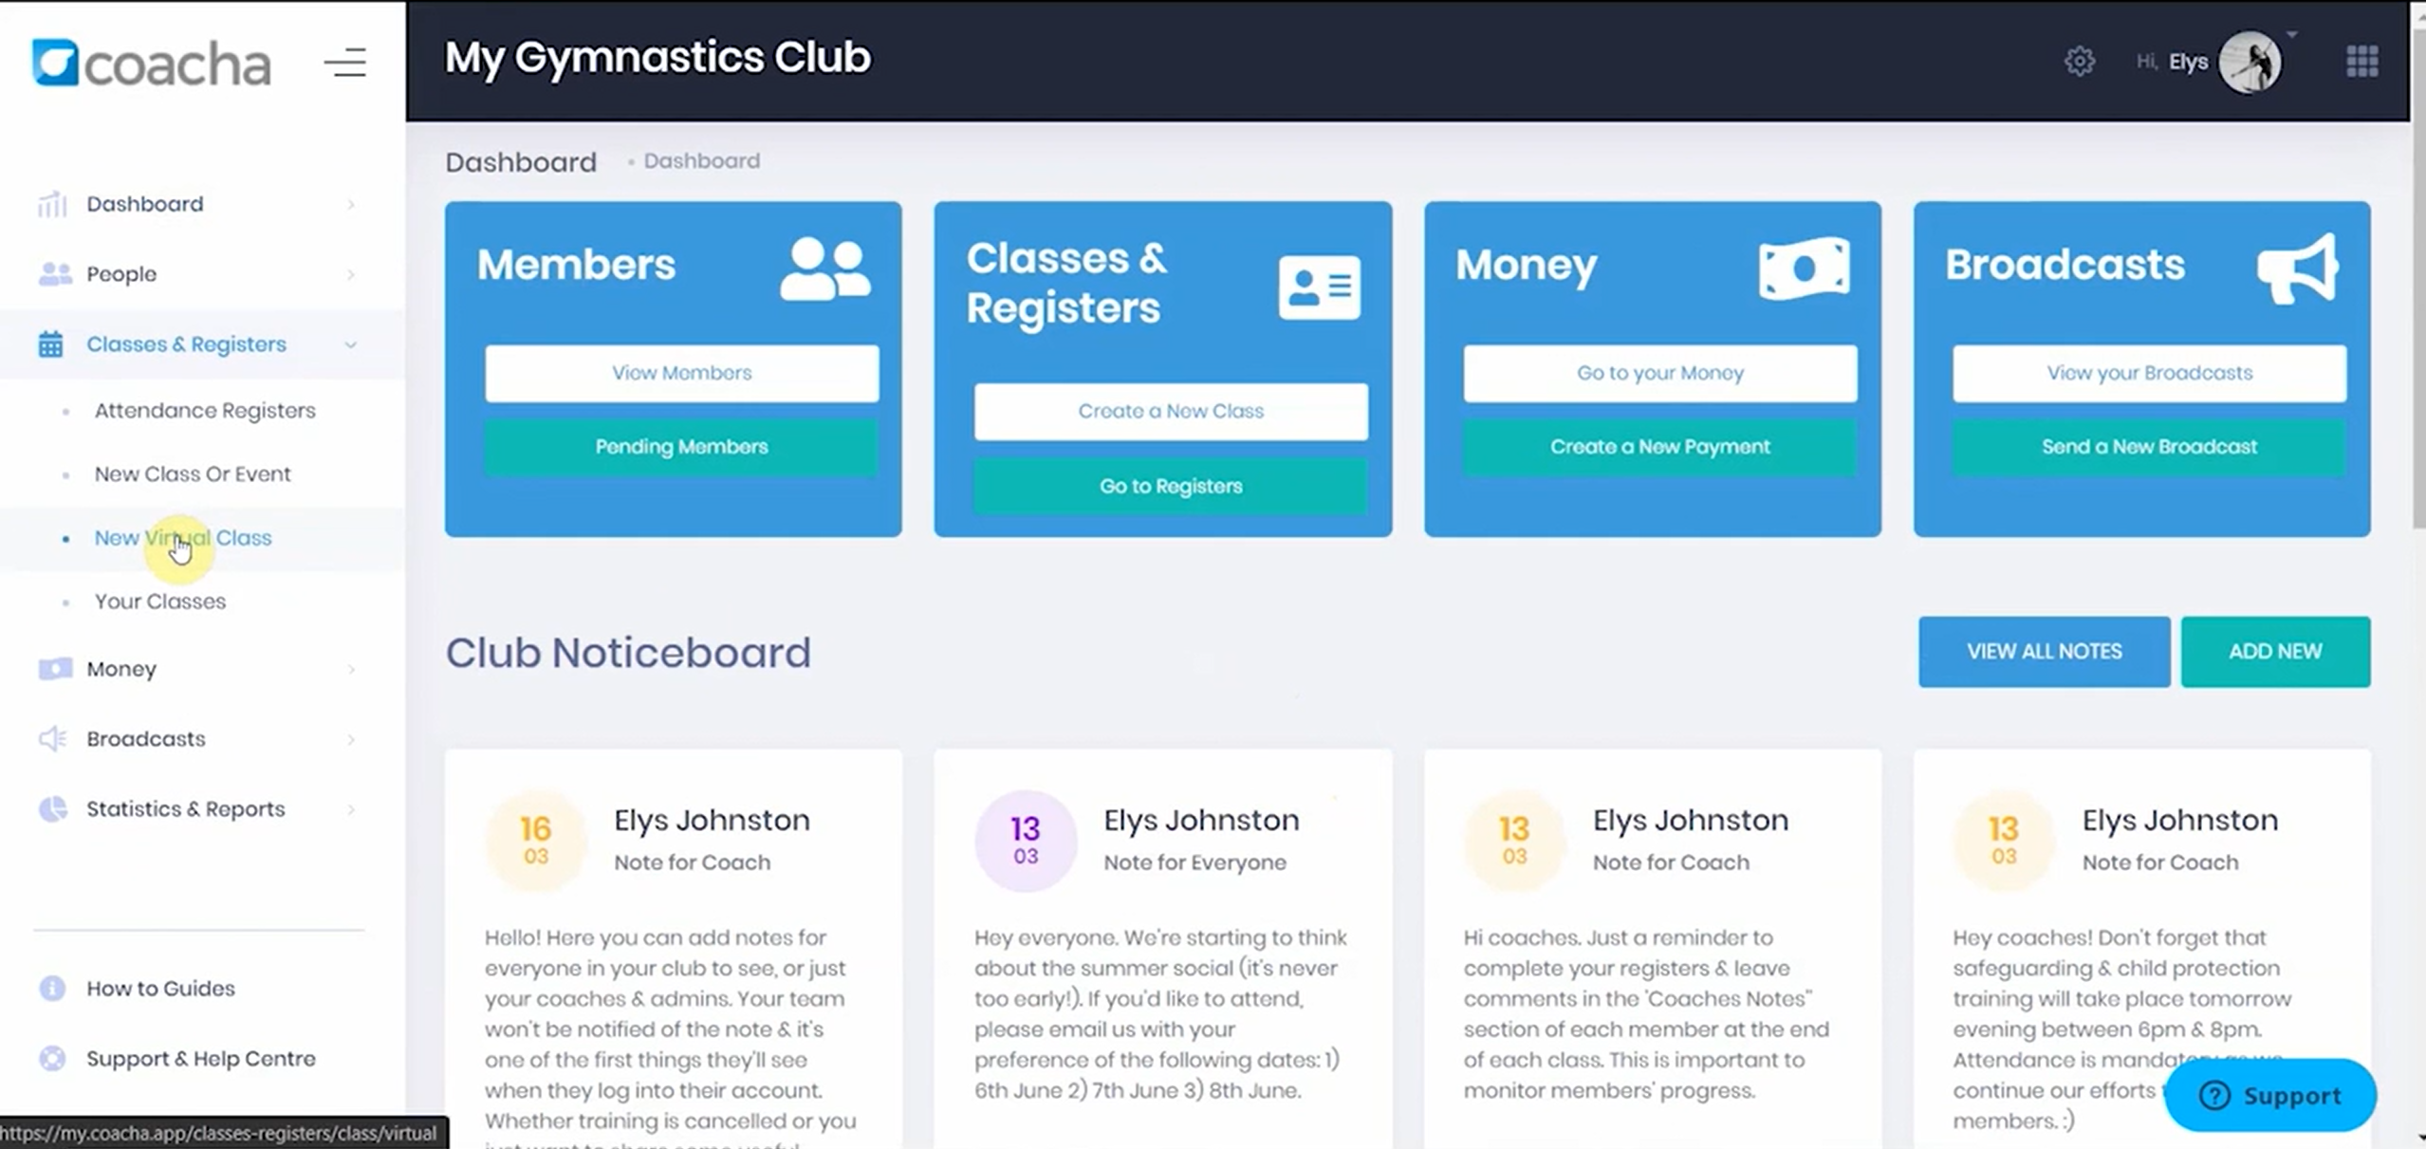
Coacha has a lot of useful features and functions, such a way to manage members, which classes are available and each of those classes’ registers, money and broadcasting information. Coacha has functions to mark students as present but not as late or absent with a reason.
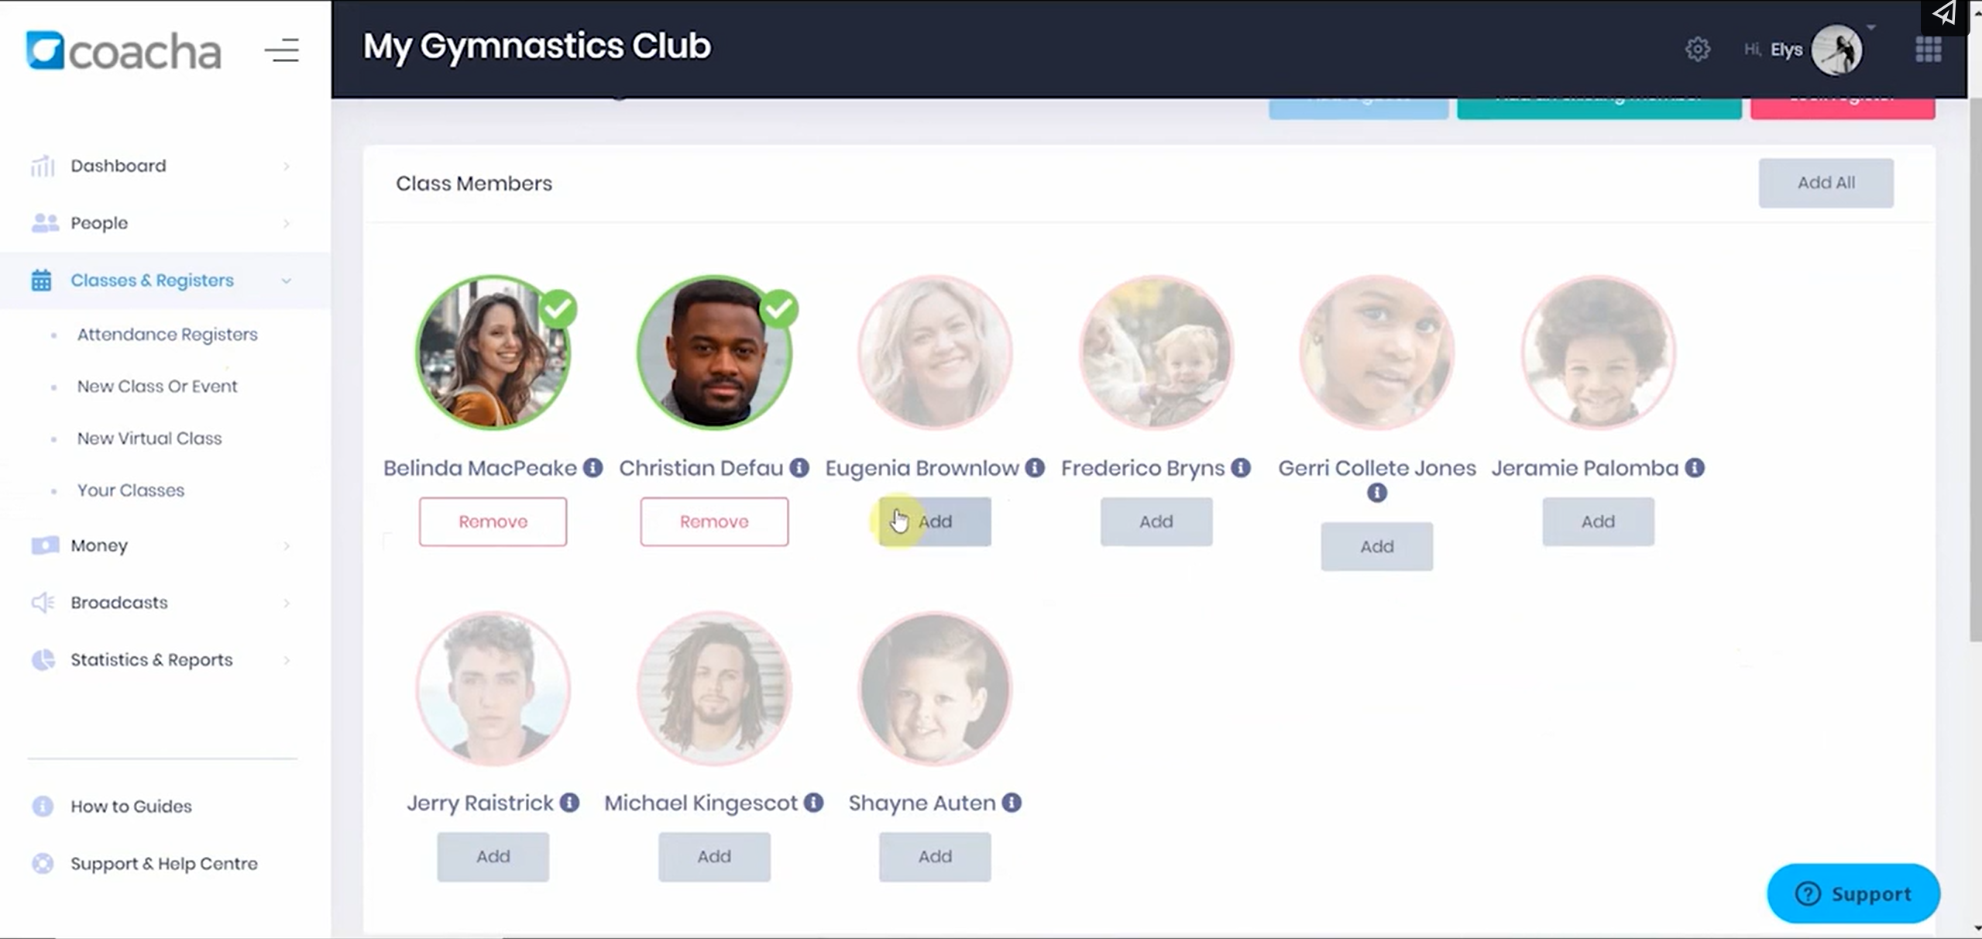
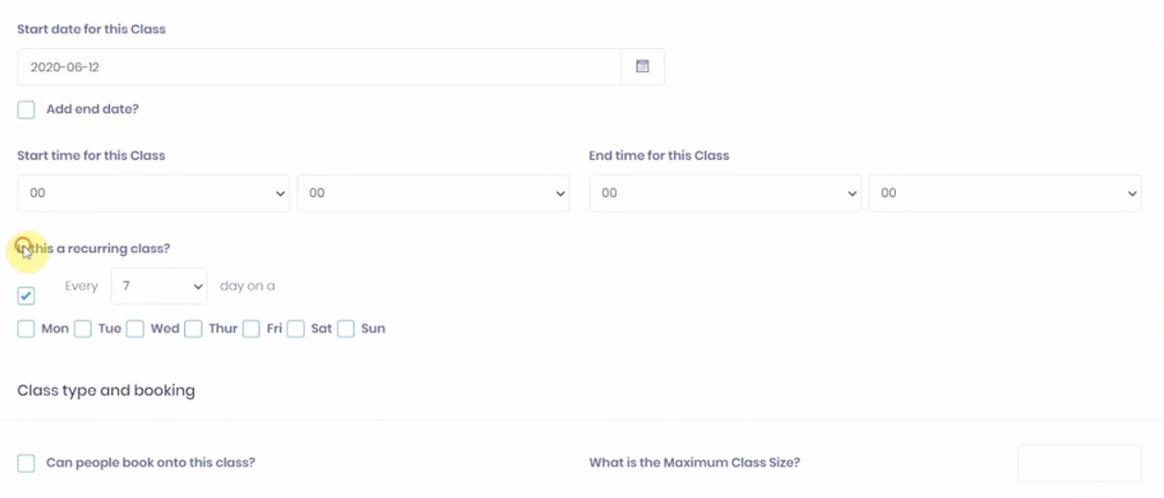
The data that is outputted is a grid of the student’s profile picture with the option to sign them in below using the add button. There are also options to add students to class elsewhere in the system and to create classes. The data required for that is Class name and description, start date, whether it is recurring or not and the timings for the class. To then add students to a class there is another grid of pictures of people with the option to add them below by clicking a button below their picture labelled add.
From this software I will keep the singular button to say that people are attending as quick to do and doesn’t have any other windows. I am going to leave out the profile picture in the register as when there are more people in a class it becomes hard to see everyone, also my client has stated that they would prefer the register without them. I also don’t need to add any classes so I will also be leaving that feature out as that is not what my coursework focuses on.

Summary table
Software name features wanted justification
Software name | Features wanted | Justification
Arbor | - How attendance is displayed on the student’s dashboard  - How the register is laid out for the teacher  - The attendance certificate  - The Timetable view for attendance  - The overview of attendance for a student | - It is short compact; gives all the details it needs to so there is no need to change it.  - This is in a nice list format which makes it easy to scroll down and see all the names.  - Good way to see all the data about one student’s attendance in one place.  - Easy way to see where the student may have been absent.  - Also, nice and shot overview of a specific student’s attendance
Inventry | - Mark all as present button | - This makes it much faster to complete a register if you know everyone is present in the class as you only have to press one button and then submit the register
Coacha | - Button to say people are attending with no extra windows | - This reduces the number of windows that you need to use which ultimately much faster than if you have an extra dialogue box which you plan on leaving empty

Features of Proposed Solution
Feature | Description | Justification
Log in page | This is to restrict different people with different levels of access to only see certain features and perform certain tasks | This is so people with not the correct levels of access can’t mess with the data and cause inconsistencies in the data
Display register | This will display a list of names to the teacher when they go to take a register | This is so the teacher can call out the names and give different students the correct mark
Select different register marks | This will display a selection of characters next to each student in the register and allow the teacher to select a mark to give the student | This is so the teacher can give different register marks to different student based on whether they are present, late or absent
Display teacher timetable | This will display the teacher timetable and highlight the current lesson that is going on | This is so the teacher can easily select the correct register to go in to and take at the correct time
Search for student | This will allow the teacher to search for a specific student by name to get an overview of their attendance | This is so, if necessary, the teacher can individually look up the student’s attendance in detail and help them locate missed lessons
Display form attendance | This will display a list of all students in that teachers form with their attendance next to their name. It will also be ordered by attendance from lowest to highest and colour coded. | This makes it easier for the teacher to check each student in her form attendance quickly and all in one place. And it is colour coded to show who she needs to talk to about their attendance
attendance certificate | This will display an entire overview of one student’s attendance in depth including percentage attendance, and a table of all register marks | This provides an entire overview of a student’s attendance in one place which makes it easier for the teacher to scan over to see where things may have been marked incorrectly
Attendance timetable (teacher) | This will display a table with lessons number as a heading and date along the side with each section of the table containing the register mark for that lesson, with it being only between specific date set by the teacher | This help to identify where a student has missed lessons or marked as late, in a concise format which can be looked over quickly
Attendance overview (teacher) | This will display some stats about a student’s attendance | This will just provide a nice overview for the teacher to quickly look at and see if they need to look deeper into where the student missed lessons
Attendance overview (student) | This will display an overview of the student’s attendance, which is just their overall percentage attendance on the student’s home page | This is so the student can quickly see their attendance and if it needs to be investigated
Attendance timetable (student) | This will display a table with lessons number as a heading and date along the side with each section of the table containing the register mark for that lesson, with it being only between specific date set by the student | This is so the student can look through on their own and see where they may have missed lessons before the teacher has to check for them saving time for the teacher

Limitations of the Proposed Solution
One limitation I have is that my current solution will have no networking functionality so it is only able to be run on one computer at anyone time and any updates to files will be stored locally on my client’s pc. This is because it is a prototype and because I am focused on the main functionality of the system rather than methods to make it a viable commercial product which will only happen after the prototype is working correctly.

Another limitation of the system is that it will have minimal user interface development. This is due to during development I am focused on functionality over user interface development as this is a prototype I am developing rather than a complete system currently.

The fact that the system will only have a keyboard as an input to the system is another limitation as it will have limited user intractability. Again, this is because I am developing a prototype, and my main focus is the core functionality of the system and making sure that is working correctly before I add more ways for the user to interact with the system.

I also won’t be developing any APIs to allow my system to communicate with other systems such as emailing systems. This is another limitation as it means that anything the software can’t do cannot be easily transferred over to another system. Once again this is because I am developing a prototype not a complete solution. This means I am more focused on developing standalone functionality for the program rather than how it can utilise other systems as well. Once functionality has proven to be robust this feature can be added.

Another limitation of the proposed solution is the size of the initial data that I have is much smaller than the data that will actually end up being used in the fully completed system. This is again because I am developing a prototype and focusing on the functionality and not focused on incorporating all the data which would come after the prototype is approved by the client and all functionality works.

Requirements

Hardware Requirements
The hardware requirements to run the system is pretty limited, all my client needs are a pc, a monitor, keyboard and mouse. The mouse is only needed to initially run the application. Then the keyboard is used to operate the rest of the program as the system runs in a command window and a mouse is not supported in mou. And the monitor is used to display the output. The hardware requirements need to be low as the computer she uses at school computers which are not very good

Software Requirements
The system requires a windows operating system as the program has been compiled into a .exe, but by using packages such as wine and winetrix (a Linux package used to emulate windows software in Linux) it is possible to run it on some Linux distributions. They would not need the ide as the idea is used to compile the program and is not needed to run it. It must be able to be run on windows as in school, where my client will run the program, the os is only windows.

File Requirements
- The data files required by the software are:
- The student file is the file that is used to store all the data bout the students including their name, StudentID and their attendance.
- The timetable file contains the information about the timetable, it keeps track of every class and when they all are using a combination of lesson number and day number to generate a table.
- The class file stores the information about every unique class including the class id and the subject id to make every class easily identifiable. It also stores the number of students in that class to make searching for those students easier
- Stored in the teacher file is all the information about the teachers such as their id and name.
- Stored in the subjects file is all the information about each subject, its name and that subject id.
- The login details file stores all the information about each person’s logins and is ordered by username to make searching it easier.
- The form file is a file that stores all the information about any form/tutor groups in the school.
- The register file stores all the information about every register like when it was taken and who was there with what register mark.
All these files are linked together using many to one relationship as you can’t have a many to many relationships, so it is broken up into a resolver file with a many to one relationship. There is also someone to one relationship between the student and the Login details file and the teacher’s files.

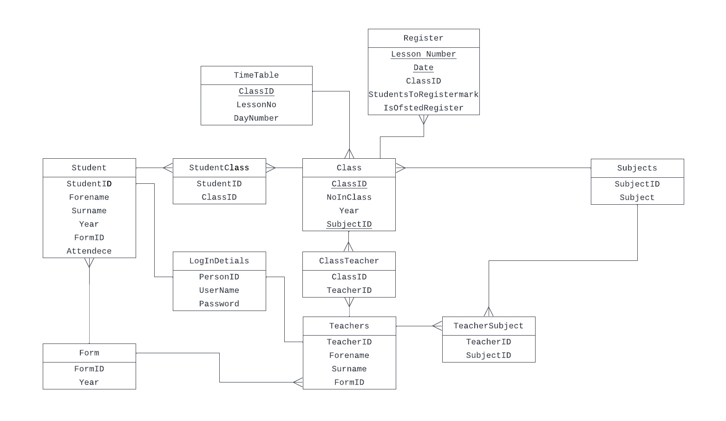
Data requirements, my client needs to store data about, normalised link relational system.

Success Criteria
Some success some measurable (not make my client happy)
Fully, mostly, partially, or not met.
Identify measurable success criteria.
Justifying- must link to a stakeholder (mostly client) – tie what stakeholder is doing to your testing.
- Store data.
  - Student Data
    - StudentID
      - To help uniquely identify each student in the file, my client would like a way to uniquely identify each student that is not name as some people have the same name.
    - Name
      - To help search for students by a more common field, my client requested this field to help her search for students as she doesn’t remember every student StudentID (fill reason for all fields)
    - Year
      - Used to sort by all students in a year, my client has asked for a way to sort students by year, so we needed a year field for each student.
    - Attendance
      - My client wants to keep track of the attendance for every student, so we need an attendance field attached to each student to keep track of
  - Timetable data.
    - ClassID
      - My client has also asked if we could keep track of the timetable data to make seeing where lessons missed easier and helping her to choose the right class at the right time. To do this we need to keep track of what class is when, so we need the ClassID.
    - Lesson Number
      - We also need to keep track of the lesson number, what lesson is it in one day (lesson 1, 2, 3…) so we know when it is.
    - Day Number
      - We also need to keep track of what day is it in the week, where Monday is day 1 through to Friday being day 5, you can then have a two-week styled timetable, this allows us with lesson number as well to get exactly when a lesson is in a week.
  - Register data.
    - Lesson Number
      - This field is required to keep track of when the register was taken.
    - Date
      - This field is the other counterpart to lesson number in telling when the register was taken.
    - Class ID
      - We also need to know which class the lesson was for, as requested by my client.

    - Student To Register Mark array.
      - My client needs a way to store what every student in that class got in that register, so we need a field to relate students to the marks that they got which I did with an array.
    - Is it an Ofsted register?
      - We then also need to know whether it is a register that needs to be submitted to Ofsted or not, as requested by my client.
  - Teacher data
    - Teacher ID
      - MY client has also requested a unique way to identify teachers as they need to be stored, so you can see which teacher did what register.
    - Name
      - My client has also requested that the names of the teachers be stored. This is so the names can be given instead of the teacherID.
  - Class data
    - Class ID
      - Each class has to have a unique way to identify each class, this is in the form of ClassID which has been requested by my client.
    - Number in class.
      - My client has also asked if we can keep track of the number of students in each class.
    - Year
      - My client also thinks that the year that the class is for will be import information to keep track of
  - Subject data
    - SubjectID
      - My client has also asked to store information about each subject and for that she has requested the subjectID to be stored to uniquely identify each subject.
    - Subject
      - She also asked for the subject name to help search for the subject as she doesn’t remember the subjectID.
  - Login data
    - Username
      - Each user will have a username to log in to the system, which has been requested by my client so that students can’t access user data.
    - Password
      - She also needs all accounts to have passwords so other people can’t access other people accounts.
  - Form data.
    - FormID
      - She also expressed the need for forms and decided upon just needing the FormID to identify the form.
    - Year
      - And she also wanted the year that the form was for to make searching for classes easier.

- Add new data.
  - Register data.
    - Lesson Number
      - Not blank because it is a unique identifier, every register must be at a certain time during a certain lesson.
      - Must be a number, can’t have a lesson number as a word or characters.
      - Must be less than 5 because there are only 5 lessons in my client’s school (do this for all in add data, check and reason)
    - Date
      - Must be a valid date so that the register can be looked back on and found.
      - Only numbers, dates can’t be not numbers.
    - Class ID
      - Must follow the key for that year this is so it can.
      - Must be an already existing class otherwise a register should not be able to be taken for it, as you can’t register a class that doesn’t exist.
    - Student To Register Mark array.
      - All students marked this is so.
      - All names are correct.
      - All names do not contain numbers.
      - All marks are only marks that are valid.
    - Is it an Ofsted register?
      - True or false only this is because it can only be true or false.
- Edit data.
  - Student Data
    - Attendance
      - Use validation rules.
  - Register data.
    - Student To Register Mark array.
  - Main tables (not resolvers) …
- Delete Data
  - How am I going to delete for each piece of data – reasons need to discuss with you?
- Output Reports
  - Content, order, headings total for each output report – reasons (is there a search criteria)
- Search for….
  - Search criteria for all things to search for - reasons.
- Sorting
- Easy interface?
  - Reason
- Login system
  - Reason

Students

Feature | Description | Measurable success criteria
Log in page | This will ask for a username and password, and depending on the status logins in depends on the tasks offered to the user | When a teacher logs in the functions will be:  View Attendance  Take a Register  And if it was a student that logs in the list of functions will be:  Attendance attendance percent: …%
Display register | This will display a list of student’s names in that class with a choice of marks next to each student name | This will display the names in a format of  Name1 - [present] [absent with reason] [absent no reason] [late]  Name2 - [present] [absent with reason] [absent no reason] [late]…  And there will be the same number of names as students in that class which can be check by outputting the number of students in that class from the class file.  With a mark all as present, mark all as absent and a submit button at the bottom
Select different register marks | This will allow the user to move the cursor between each student and each option and selecting the option just by moving on to the next student. And them submitting by pressing enter | The end display will look like  Name1 - [present] [absent with reason] [absent no reason] [late]  Name2 - [present] [absent with reason] [absent no reason] [late]  Name3 - [present] [absent with reason] [absent no reason] [late]…  [Mark All Present]  [Mark All Absent]  [Submit Register]
Display teacher timetable | This will display the teachers timetable and highlight the current lesson that it is. The timetable will be displayed with day along the top with date above that and then lesson numbers down the sides | The data will look something like this with classes and the highlighted one is the current lesson that they need to do the register for
   | 01/07/24 | 02/07/2024 | 03/07/2024 | 04/07/2024 | 05/07/2024
   | Monday | Tuesday | Wednesday | Thursday | Friday
  1 | 9AT1/Ch | 9AT2/Ch | 9AT1/Ch | 9BT1/Ch
  2 | 9AT1/Ch | 9AT1/Bi |  | 9BT1/Ch
  3 |  | 9AT1/Bi | 9BT1/Bi |  | 9AT1/Ch
  4 | 9BT1/Ch |  | 9AT1/Bi | 9BT2/Bi
  5 | 9BT2/Bi |  |  | 9AT2/Ch
Search for student | There will be a search bar provided that can be typed into and will display all students which are close to what they have typed in, they can then navigate down to each student and then select the student | Search for name: R.  Robert Cole  Rita Gamble  Rose Roberts  Robert Flores…  This will refine as more letters are typed in, the selected one can then be selected by pressing enter and you will enter the overview for that student
Display form attendance | This will display a list of all students in that teachers form with their attendance next to their name and colour coded to highlight the students that need talking to. This will also be ordered from lowest attendance to highest attendance | Wendell Hulslander – 75%  Marylouise Brooks – 83%  Rose Roberts – 92%  Tracy Boyd – 95%  Velma Morris – 99.8%  This is what an example set of data should look like when looking through the teachers for attendance
attendance certificate | This will display all information about the student’s attendance. Including percentages and a table of where they missed lesson. | Name: Wendell Hulslander  Attendance: 75%  Authorised absences attendance: 89%  Unauthorised absences: 14  Lates: 12  …  IT should show the students name, attendance, attendance with authorised absences, unauthorised absences and late marks. It should then also have a table and all marks in that year.
   | 1 | 2 | 3 | 4 | 5
  05/07/24 | /\ | L | A | L | /\
  04/07/24 | L | A | A | /\ | /\
  03/07/24 | /\ | /\ | /\ | /\ | L
  02/07/24 | L | /\ | A | /\ | /\
  01/07/24 | L | L | A | /\ | A
Attendance timetable (teacher) | This will provide a timetable for the student with all register marks for a ser period of time | Name: Erica Hernandez  …  This is a display of all register marks between two time periods set by the teacher when entering this view
   | 1 | 2 | 3 | 4 | 5
  05/07/24 | /\ | L | A | L | /\
  04/07/24 | L | A | /\ | /\ | /\
  03/07/24 | /\ | /\ | /\ | /\ | L
  02/07/24 | L | /\ | A | /\ | /\
  01/07/24 | /\ | /\ | /\ | /\ | A
Attendance overview (teacher) | This will bring up a display giving the name of the student, overall attendance, Attendance with authorised absences, Unauthorised absences and late marks | Name: Ann Lavoie  Attendance: 85%  Authorised absences attendance: 93%  Unauthorised absences: 4  Lates: 2
Attendance overview (student) | This will give the student a quick overview of all of their attendance statistics, which is the same as what the teacher will see. It will display overall attendance, attendance with authorised absences, Unauthorised absences and late marks | Attendance: 89%  Authorised absences attendance: 96.4%  Unauthorised absences: 1  Lates: 0
Attendance timetable (student) | This will give the student a week-by-week view of all of their register marks over the whole year which they can cycle through to see when they have missed lessons or were marked as late | This will display a 5-day week from Monday to Friday with lesson numbers as headings and it will display all the register marks that have been marked down that week. So, from my example data one example could look like this.
   | 1 | 2 | 3 | 4 | 5
  01/07/24 | /\ | L | A | /\ | /\
  02/07/24 | /\ | /\ | /\ | /\ | /\
  03/07/24 | /\ | /\ | /\ | /\ | L
  04/07/24 | /\ | /\ | /\ | /\ | /\
  05/07/24 | /\ | /\ | /\ | /\ | A

Design

Problem Decomposition

Required Files and Entity-Relationship Diagram

Initial data files with justification

Top-Down Design – script n.

Pseudocode – script n

Top-Down Design – script n+1.

Pseudocode – script n + 1

Usability Features

Data Dictionary

Validation

Initial Test Data Plan

Iterative Development and Design

Iteration 1
Aim – 3 aims (in this iteration I will ____) 3 sentences.
Design: don’t do till after holidays
Code:
Testing – testing loops, selection, validation…

Evaluation – does the code meet the success criteria, does it meet the aims? Talk to your client.

